Homework 8 – Top-Down Design

Write a program named hw8.py that implements the hangman game. Hangman is a simple letter guessing game. The program picks a word (from a file) and displays it with underscores replacing the letters. The user tries to guess the word by guessing one letter at a time. The user loses if they guess too many incorrect letters. For your program, set the maximum number of incorrect guesses to 4.

The program should randomly choose a word from a file of words (e.g. words.txt). The name of the file should be entered as user input. The file should be a plain text file with words separated by a space, and they can be on multiple lines.

Validating the user's guess input:
- The user should be able to enter either upper or lowercase letters.
  - (if input is lower case, it will find BOTH upper or lower case in the answer)
- Validate that the user entered a letter and only 1 letter, re-prompt until it is valid.
- Tell the user if they have already guessed the entered letter (and don't count it as an incorrect guess) and re-prompt.
- Update the display after each guess and tell the user how many incorrect guesses they have left.

You MUST write this homework using the design explained in the lectures this week without modification. See the design diagram for clarification.

Your program MUST include the following functions. Do NOT change the function headers shown below:

printGreeting(): Prints the program greeting.

readWords(filename): Takes the name of the file to read, reads in the words from the file into a list, and returns the list of words.

playGame(words): Takes the list of words, calls getRandomWord(), and loops until the game is either lost or won.

getRandomWord(words): Takes the list of words, randomly chooses a word (using Python random library), and returns the secret word.

displayTurn(numMissedLetters, correctLetters, secretWord): Takes the number of incorrect guesses, the list of correct guesses, and the secret word. Displays the secret word, with correctly guessed letters visible and the other letters “hidden” with an underscore, and displays the amount of incorrect guesses left.

getGuess(allGuessedLetters): Takes a list of all the guessed letters (both correct and incorrect). Gets a letter input from the user, checking if it is valid (see “Validating the user's guess input” above), looping until a valid guess has been made, and returns the guessed letter.

wonGame(correctLetters, secretWord): Takes the list of correct guesses and the secret word, returns True if the game has been won and False if not.

lostGame(numMissedLetters): Takes the number of incorrect guesses, return True if the game has been lost (too many bad guesses) and False if not.

playAgain(): Prompts the user if they want to play again. Returns True if yes and False if no.

Design Diagram
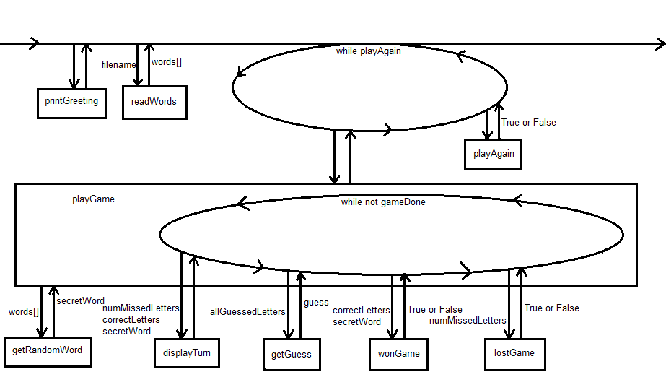
Sample output:
$ python hw8.py
-----------------------------------------------------------------
H A N G M A N
-----------------------------------------------------------------

Enter the name of file holding words: words.txt

_ _ _ _ _ _ incorrect guesses left: 4

Guess a letter: e
Yes, there's a e

_ _ _ _ e _ incorrect guesses left: 4

Guess a letter: s
Yes, there's a s

s _ _ _ e _ incorrect guesses left: 4

Guess a letter: o
Yes, there's a o

s _ o _ e _ incorrect guesses left: 4

Guess a letter: m
Sorry, no m

s _ o _ e _ incorrect guesses left: 3

Guess a letter: n
Yes, there's a n

s _ o _ e n incorrect guesses left: 3

Guess a letter: m
You already guessed that letter. Choose again.
Guess a letter: wd
Must enter a single letter.
Guess a letter: 3
Please enter a LETTER.
Guess a letter: p
Yes, there's a p

s p o _ e n incorrect guesses left: 3

Guess a letter: k
Yes, there's a k

You won! The word is SPOKEN

Play again (y or n)? y

_ _ _ _ _ _ incorrect guesses left: 4

Guess a letter: q
Sorry, no q

_ _ _ _ _ _ incorrect guesses left: 3

Guess a letter: z
Sorry, no z

_ _ _ _ _ _ incorrect guesses left: 2

Guess a letter: x
Sorry, no x

_ _ _ _ _ _ incorrect guesses left: 1

Guess a letter: v
Sorry, no v
Sorry, you're out of guesses.
Play again (y or n)? n

Remember, all input must be validated and be sure you handle I/O exceptions. You can assume the content of the file will be valid, but the location of the file will need to be checked.

After you've finished your assignment, use the submit command to turn it in.

You must be logged into your account and you must be in the same directory as the file you're trying to submit.

At the Linux prompt, type

submit cs201 HW8 hw8.py

After entering the submit command shown above, you should get a confirmation that submit worked correctly:

Submitting hw8.py...OK

If not, check your spelling and that you have included each of the required parts and try again.

You can check your submission by entering:

submitls cs201 HW8

You should see the name of the file that you just submitted, in this case HW8.py

