Homework 6 – Loops

Write a small game program named hw6.py. Each cycle, draw out a simple 8x8 ASCII game board. The board should have a border and spaces, the position of the player (“P”), and the position of the magic key (“K”). Then get input from the user of which direction they want to move ("North", "South", "East", "West"). Update the player's X,Y coordinates and begin next cycle to redraw the board. Do not let the player move onto the border. Cycle until the player reaches the key, print that they won the game, and exit.

For example:

Welcome to the Loops HW. Get to the key!!!

-------------------
| . . . . . . . . |
| . . . . . . . . |
| . . . . . . . . |
| . . . . . . . . |
| . . P . . . . . |
| . . . . . . . . |
| . . . K . . . . |
| . . . . . . . . |
-------------------
North, South, East or West? south
-------------------
| . . . . . . . . |
| . . . . . . . . |
| . . . . . . . . |
| . . . . . . . . |
| . . . . . . . . |
| . . P . . . . . |
| . . . K . . . . |
| . . . . . . . . |
-------------------
North, South, East or West? east
-------------------
| . . . . . . . . |
| . . . . . . . . |
| . . . . . . . . |
| . . . . . . . . |
| . . . . . . . . |
| . . . P . . . . |
| . . . K . . . . |
| . . . . . . . . |
-------------------
North, South, East or West? South

You found the magic key!

In main, set the key's position to (3,6) and the player's beginning position to (2,4).

Remember, the coordinate system we are using has 0,0 in the upper left.
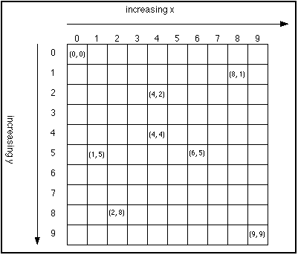

Write the function printBoard(playerX, playerY, keyX, keyY) that takes the XY coordinate positions of both the player and the key, and prints out the entire board.

Then, in main() get the direction from the user. Validate the input.

Write the function updatePosition(direction, playerX, playerY) that takes the direction the user entered, the original player's X and Y, and returns the updated player's X and Y.

You can return 2 values from a function:
def set2vars(x, y):
x += 1
y -= 1
return x, y

def main():
u = 4
v = 4
q, r = set2vars(u, v)
print q, r

main()
This would print out:
5 3

Write the function offboard(pX, pY) that takes the player's new XY position and return True if they are now on the border and False if they are not. Add a call to offboard() in updatePosition().

Write the function reachedKey(playerX, playerY, keyX, keyY) which returns True if the player reached the key and False if not.

Finally, edit main() so that the program keeps going until the player has reached the key.

When you've finished your homework, use the submit command to submit the file.

You must be logged into your account and you must be in the same directory as the file you're trying to submit.

At the Linux prompt, type

submit cs201 HW6 hw6.py

After entering the submit command shown above, you should get a confirmation that submit worked correctly:

Submitting hw6.py...OK

If not, check your spelling and that you have included each of the required parts and try again.

You can check your submission by entering:

submitls cs201 HW6

You should see the name of the file that you just submitted, in this case hw6.py

