CMSC 101 – Finite-State Automata and Complexity Exercises
November 12, 2013

These are examples of the types of questions you may see on the final exam. If we have time in class, we’ll work through some of these; if not, you can use them as a study guide. I will send you solutions if you ask me for them, but you should try to solve them on your own first to get the most out of them.

- The following questions refer to the FSA shown here. (For each input, the FSA starts in the state marked “S.”)
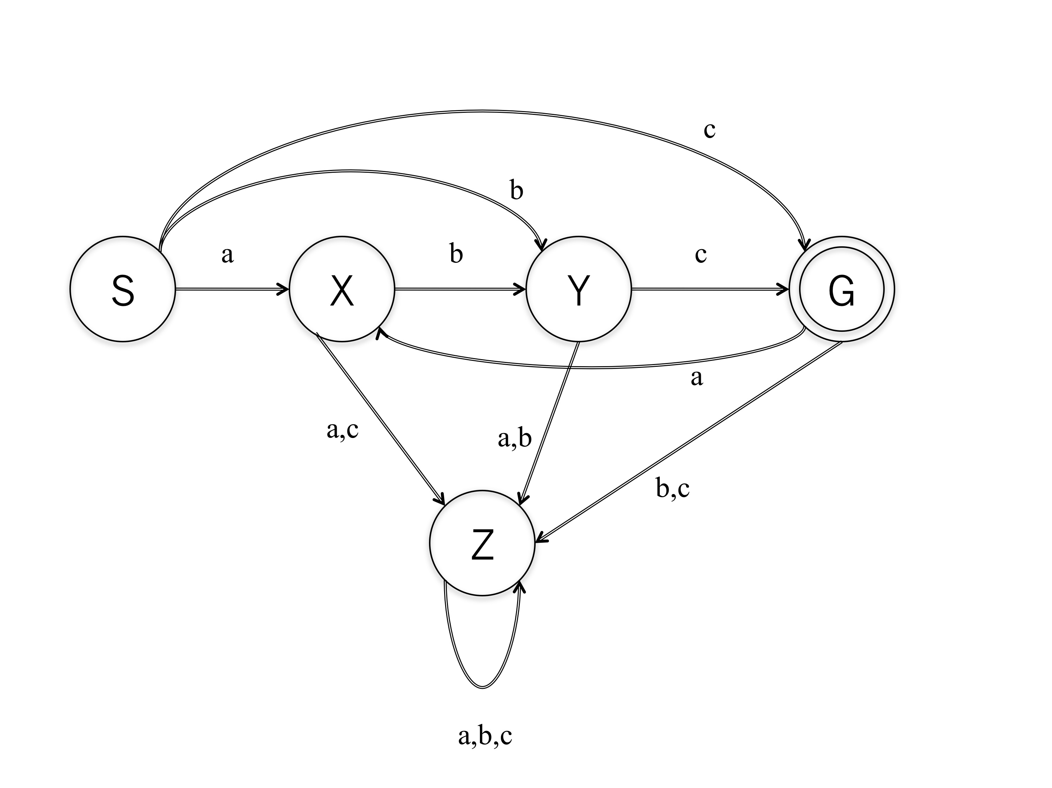
  - List two different input strings that are accepted by the FSA shown above.
  - List two different input strings that are not accepted by the FSA.
  - What state will the FSA end in, given each of the inputs below? Does the FSA accept that string, or not?
    - abc
    - cba
    - cabc
    - bcab
    - aaaaa
  - Challenge question: Describe the set of strings that are accepted by the FSA pictured above.
- Draw a finite state automaton that will accept (end in a double-circled state) the set of binary strings that consist only of “1”s (i.e., no “0”s are seen). (All other strings should cause the FSA to end in a non-double-circled state.)
- Given the following running times (in units: nanoseconds—or whatever...) for algorithms operating on a list of length n, state whether each algorithm’s big-O complexity (dominant term) is constant, linear, logarithmic, polynomial (and if so, the degree of the polynomial), or exponential.
  - 17n² + 4.3
  - 100,000,001
  - 16 n log n
  - 5^{n} + n¹⁷ + n² + 400,000,000,000,000
  - 5 + 2n⁴
  - 2 log 4n

- This pseudocode algorithm suggests three-person study groups consisting of students who have a GPA within 0.5 of each other. If there are n students, what is the maximum number of study groups this algorithm could suggest? What is the complexity of the algorithm?
// GPAs and Names are arrays that have already been set up
for ( i=0 ; i<length ; i++ ) {
for ( j=0 ; j<length ; j++ ) {
for ( k=0 ; k<length ; k++ ) {
if ( ( i != j ) && ( i != k ) && ( j != k ) ) {
( abs(GPAs[i] – GPAs[j]) <= 0.5 ) &&
( abs(GPAs[i] – GPAs[k]) <= 0.5 ) &&
( abs(GPAs[j] – GPAs[k]) <= 0.5 ) ) {
print (Names[i], “ and ”, Names[j], “ and ”, Names[k],
“ would make a good study group!”)
} // end if statement
} // end 3rd for statement
} // end 2nd for statement
} // end 1st for statement

