CMSC 100 – Fall 2012
Homework #5
Handed out Thursday, 11/1/12
Due Tuesday, 11/20/12

Security (50 pts)
- (10 pts) (S&G Exercise 8.4, page 417.) Merriam-Webster’s Collegiate Dictionary,11th ed. (Merriam-Webster, Inc., 2003), contains over 225,000 entries. Using a password-cracking tool that can process 1.7 million words per second, how long would it take to test each word in the dictionary as a possible password?
- (15 pts) (S&G Exercise 8.15, page 418. Note: You must show your work for all steps in this problem.) Using the RSA encryption algorithm, let p=3 and q=5. Then n=15 and m=8. Let e=11.
- Compute d.
- Find the code for 3.
- Decode your answer to part (b) to retrieve the 3.
- (25 pts) (S&G Challenge Work 8.2, page 419) Find information about a well known computer virus or worm. Answer as many of the following questions as you can, and be sure to list your sources. (Note: You should locate at least two different sources of information, and include a statement to the effect that those sources do not provide the requested information for any omitted sections. Also note that as with all assignments in the class, the words you submit must be your own—you should only use quotes where absolutely necessary for clarity, and most put quotation marks around those quoted passages.)
- What is the name of the virus or worm?
- When did it first appear?
- Who wrote it?
- How was it spread?
- What systems did it attack?
- What were its observable effects?
- What are the technical details on how it worked? (Note: You don’t need to give more than a few sentences to a paragraph of high-level information about the general method that the virus/worm used to infect and possibly damage the infected systems.)
- What was the “cure”?
- Did it spawn “copycat” attacks?
- What was its economic impact?
- Was the perpetrator found, arrested, and/or convicted?

Artificial Intelligence (50 pts)
- (25 pts) Below is a map of part of the Washington, D.C., Metro system. Suppose that an intelligent agent wants to plan a route from Foggy Bottom to Judiciary Square, and that traveling from one station to the next takes more time on some lines than others (red: one minute, blue/orange: two minutes, yellow/green: three minutes). (In this problem, then, time is cost!) When a branch point is reached, the agent always generates the successor states in the following order: straight (staying on the same color), right (facing the direction it was traveling), then left. For example, if the agent had searched from Mt. Vernon Square to Gallery Place, it would then consider going to Archives (straight), then Metro Center (right), then Judiciary Square (left). The agent is smart enough to know that traveling in a loop is pointless, so if it ever reaches a station it’s already visited, it stops exploring in that direction. If it hits the edge of this submap, it can’t continue so must abandon that path as a dead end. (Note: the two blue/orange stations at the east side of the map are Federal Center SW and Capital East.)

For each of the following search techniques, show (i) the final solution (i.e., the path that it finds from Foggy Bottom to Judiciary Square) and (ii) the cost of its final solution. You may find it helpful to write out the queue at each search step (and it may help us in giving you partial credit), but you do not have to include this with your answer (and it is possible to find the right answer without writing out the queue, if you understand how the search methods work).
- Depth-first search.
- Breadth-first search.
- Uniform-cost search.
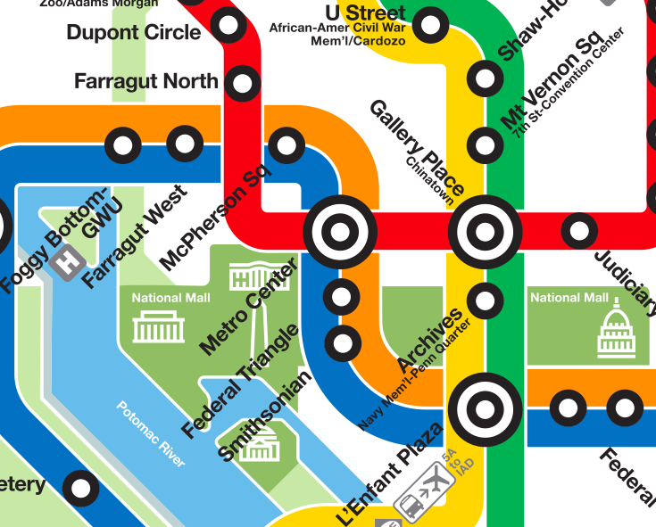
- (25 pts) Draw the minimax game tree for the game of Nim starting with six tokens. (Reminder: in Nim, each player must remove either one or two tokens on his/her turn.) Assuming that both players always take the best move for them, will the starting player (a) always win, (b) always lose, or (c) sometimes win and sometimes lose?

