Homework 5 – Functions

Write a program named hw5.py to convert between number systems.

Your program should present the user with a menu, and have these options:
- Convert Decimal to Binary (0 to 255 valid range)
- Convert Decimal to Hexadecimal (0 to 255 valid range)
- Convert Binary code to Decimal (00000000 to 11111111 valid range)
Then prompt them for which number system they want to convert from and to, and then for the input. The input can ONLY be a positive number up to 255 (to convert to BINARY) or 8 bit Binary String to be valid.

Here’s how to convert either Binary or Hexadecimal into a Base 10 number (see Figure 2 and 3):

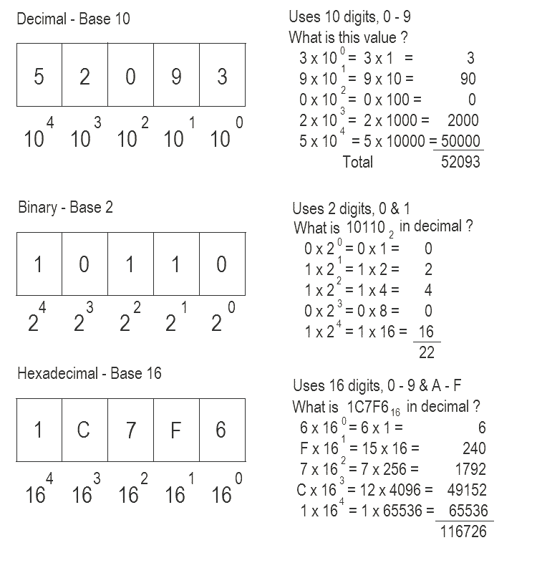

Your program should validate the input. You should validate the menu choice and, depending on the convert-from system, validate the number entered (e.g. if they choose to convert from binary, the number should only
You MAY NOT use the Python built in functions bin(), oct(), or hex(). You may use other functions if you wish, but your program must implement the following functions:

# your file header here

# def printGreeting():
# explains the program to the user

# decToHex(): Takes a decimal number, and converts it to a
# hexadecimal number
# input: decimal number as a string
# output: hexadecimal number as a string

# decToBin(): Takes a decimal number, and converts it to a
# binary number
# input: decimal number as a string
# output: binary number as a string

#binToDec(): Takes a binary number, and converts it to a
# decimal number
# input: binary number as a string
# output: decimal number as a string

def main():
# the skeleton of the program

The name of each function above must match. Any others you wish to add can be named judiciously.

Here is a running example:

$ python hw5.py
This program will convert values.
[A] - Convert from Decimal to Binary
[B] – Convert from Decimal to Hexadecimal
[C] – Convert form Binary to Decimal
[D] - Quit

What's your choice? A
Enter the number: 28b
Invalid number, try again: 28

Your number converted: 00011100

[A] - Convert from Decimal to Binary
[B] – Convert from Decimal to Hexadecimal
[C] – Convert form Binary to Decimal
[D] - Quit

What's your choice? Q
Invalid option, try again: C
Enter the number: 11010
Invalid bit pattern, must be 8 digits long, try again: 11010001

Your number converted: 209

[A] - Convert from Decimal to Binary
[B] – Convert from Decimal to Hexadecimal
[C] – Convert form Binary to Decimal
[D] - Quit

What's your choice? D
Above is just an example. We will test with other values!

Your program must have the same options and run exactly like the running example above. Notice the validation. There is:
- making sure the input match the given menu options
- the size of the binary pattern is 8 bit
- making sure the input is a number (options with a decimal value)
- could be more!! be careful!!
- Menu can accept lowercase letters (then convert)

The graders will try to break your code. Please test your code thoroughly! Also, please try even and old values for converting Decimal into whatever type.

When you've finished your homework, use the submit command to submit the file.

You must be logged into your account and you must be in the same directory as the file you're trying to submit.

At the Linux prompt, type

submit cs201 HW5 hw5.py

After entering the submit command shown above, you should get a confirmation that submit worked correctly:

Submitting hw5.py...OK

If not, check your spelling and that you have included each of the required parts and try again.

You can check your submission by entering:

submitls cs201 HW5

You should see the name of the file that you just submitted, in this case hw5.py

