Agent Monitoring Agent

Introduction:
Agent Monitoring Agent is an agent to monitor activities and communication of all other agents in an agent-based system and the result will be presented to system manager or be used for limited automatic system management

AMA Structure:
AMA has two parts: AMA server and user interface. The server collects all monitoring information from the agent-based system, make necessary disposal and then send to the user interface. The user interface shows monitoring result to the user and has buttons to get the user’s operating command.

Server
Agent 1
Agent 2
Agent 3
User Interface
AMA
Agent-based System

AMA Structure

New Agent Registration:
Each new agent of the agent-base system registers itself at the AMA server when it is created. Agent information will be sent to the AMA server, including agent name, agent address, time etc. When the server hears from a new agent, it will issue a port number to the agent. The new agent takes back the port number and opens a back socket that will be used for further communication.

Server
Agent 1
Port #
agent info.

Agent Registration

Monitor Agent Communication:
An important feature of an agent-based system is that agents can communicate with each other independently. With AMA, when one agent sends a message to another agent, a monitoring message will be automatically sent to the AMA server. The AMA server checks the monitoring message, and ultimately correct monitoring messages will be sent to the user interface and shown to the users.

Server
User Interface
Agent 1
Agent 2
message
monitoring message

Agent Communication

Ping – Active Agents:
A useful feature of the user interface is a “ping”. When a user clicks the ping button, a “ping” message will be sent to the AMA server. The server then starts to “ping” every agent on its agent list. The server sends a “ping” message to the back socket of one agent and waits for feedback. If the agent is still active, it will return an “OK”. Then the server put the agent into its active agent list. If nothing comes back, the server will wait for 30 seconds (this is an arbitrary time). If still nothing happens, the agent will be regarded inactive. The server checks all the agents and then make an updated active agent list which is sent to the user interface.

Server
Agent 2
User Interface
ping
ping
ping
OK
Ping
Agent 1
Active Agent List

Ping – Active Agents

Implementation:

Super Class Agent
As discussed before, every new agent will register itself with the server. However, we expect it can monitor an agent-based system without interfering or changing it, and the system has no knowledge about that. In other words, any agent is not aware that it is being monitored. Consequently, we make a super class agent which is inherited by each agent. The super class will deal with registration, getting a port number from the server and opening a back socket. It will also register its capabilities such as whether the agent can be monitored or pinged.

Socket Class:
The Socket class in Java library allows us to make communication among agents. To meet our needs, we wrote our Socket class which has all features of Java Socket class and, very importantly, will report to the AMA server when any communication happens. After that, we make our package of our Socket class which will be added to users’ class-path. Therefore, the agents can still use Socket class to make any communication as usual, but actually, they are using our Socket class. That’s how we get monitoring information.

AMA Server:
The AMA server is a Java application acting like an information disposing and communication center. It registers new agents and issues port numbers. Receiving monitoring messages, the server will check and send correct ones to the user interface. Besides, it will listen to the command from the user interface and act as expected. It will ping the agents, make an active agent list and send it back to the user interface.

User Interface:
The user interface is where we show monitoring result and send our commands to AMA. It’s quite simple now. Upper part of the user interface is the monitor box, where all monitoring messages will be displayed. The lower part is for “ping”. The ping box is to show the result of ping, i.e., the active agent list, and the ping button has been explained before. The user interface is a Java applet.

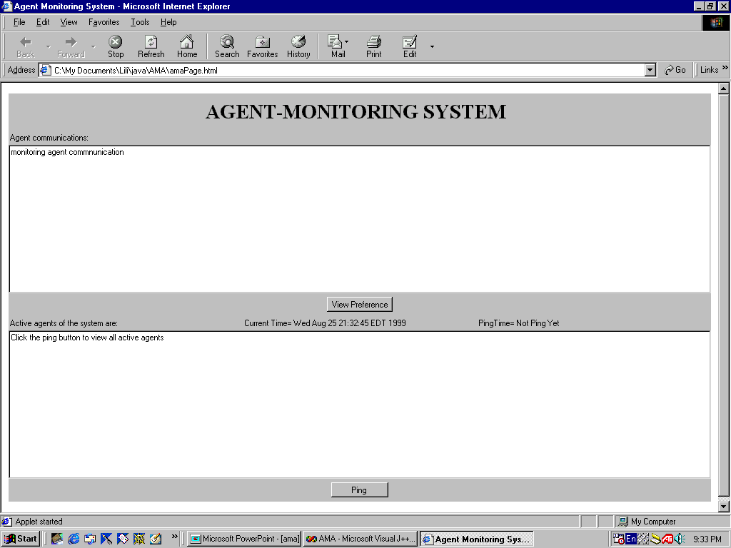

Adding More Features:
To make AMA more powerful and user friendly, we are adding more features to it. Previously, when a monitoring message arrives, it appears in the monitor box of the user interface, with all its fields: sender, receiver, message, time etc. But what if the user doesn’t want to see all of them? That’s why a “view preference” button is added. When the button is clicked, a “view preference” window is popped up, allowing the user to choose the fields he wants to view of the monitoring messages.
When the user clicks the ping button, he will get the current active agent list. But what if he’s busy and forgets to ping now and then? It’s possible that he keeps viewing an out of dated list. Therefore, we’re working on “automatic ping”. The user interface will ping automatically if the ping button is idle for 20 minutes to assure the user get recent information.

Future Plan:
In the near future, we will refine current features of AMA and will add retrieve ability to it. The user will be able to get more from the monitoring messages, for instance, search by attributes such as sender, receiver. We will also allow the user to view the history of agents, like last active time of an agent. And we will have many more.

